Pat Reynolds
Deployment 3
10/8/22
Deploying software to a separate VPC

Step 1: Setting up the EC2 instances

- Installed Jenkins on first ec2
- Installed Java runtime environment(required for jenkins agents, as well as jenkins itself) on second ec2. Nginx, Python3-pip, and python3.10-venv
- Connected the agent ec2 to Jenkins.
- Edited the jenkins ec2’s nginx file to listen to the flask application’s port 5000.

Step 2: Setting up the Jenkins pipeline

- Created multibranch pipeline, manually edited jenkinsfile to have my build, test, and deploy steps.
- Connected github account and attempted to run the pipeline. Build stage failed.
- After reconfiguring the Jenkins EC2, my testing stage failed. Will elaborate in issues section.
- Deployment stage never finished, addressed by recreating and validating my agent.
- Jenkins reported app as deployed. However site did not come up.
- Website deployed when manually running the commands.
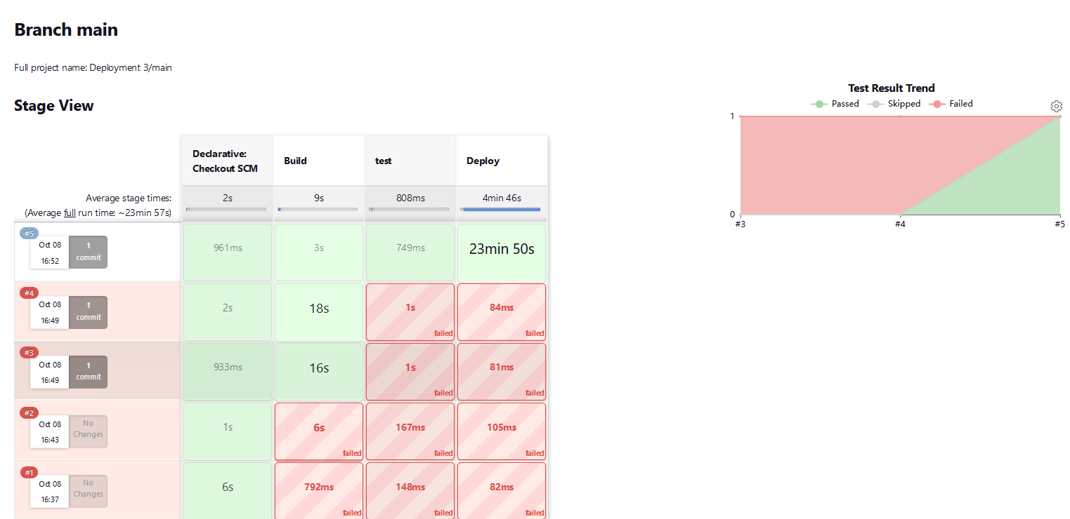

ISSUES:
- Build stage failure was due to forgetting to install python 3.10-venv and pip on Jenkins ec2. So the initial build was unable to continue.
- Testing phase failure. The test for the greet function did not equal the expected value due to a space. Changed the test in the repository.
- Did not have header for the RSA private key, or the ending =’s so Jenkins was unable to detect what format the key was in to validate it.
- Jenkins automatically will terminate any process after it completes the stage it is currently on. So the Gunicorn application is terminated after the deploy stage is finished.

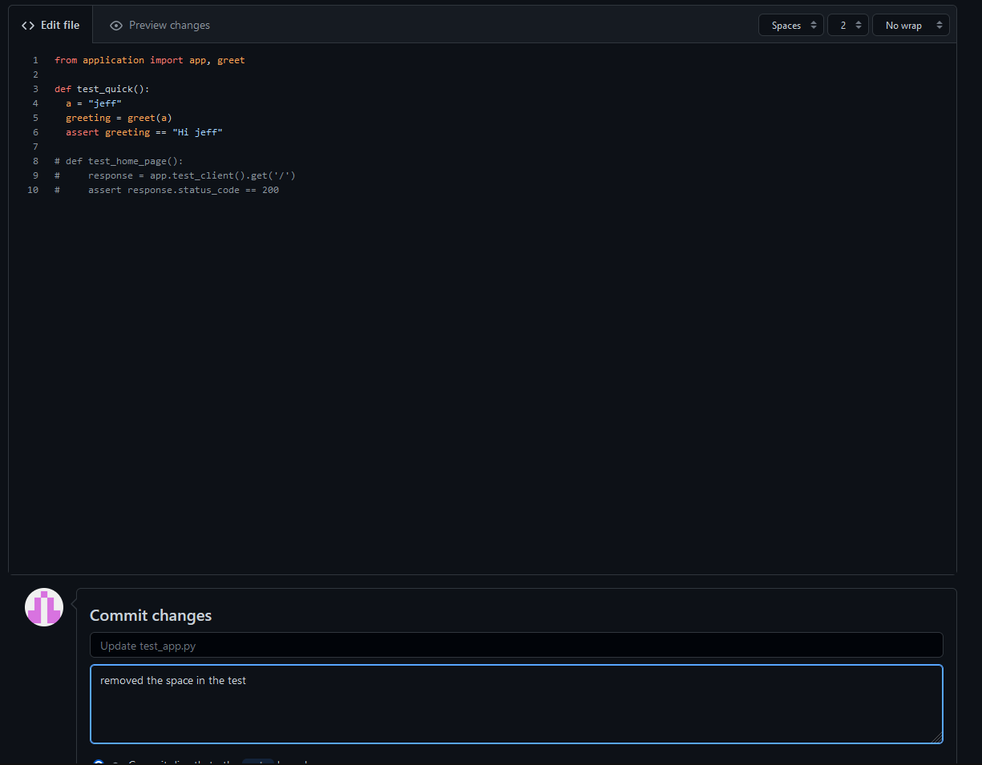

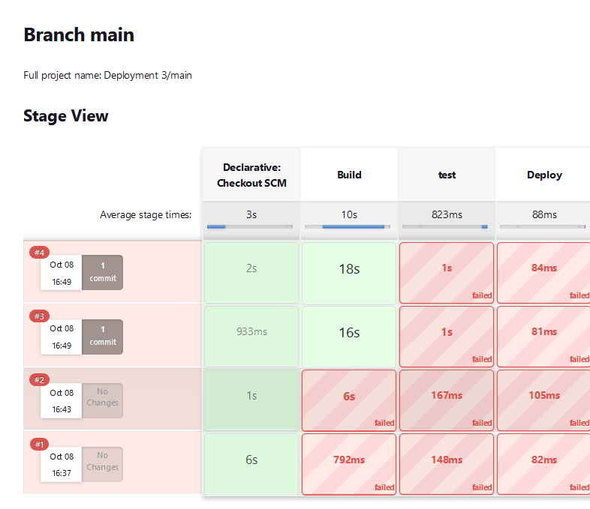

Step 3 – Fixing and modifying the pipeline

- It wouldn’t be a proper deployment if I had to manually deploy the application every time, so a fix was applied.
- The Jenkins plugin “Pipeline Keep Running Step” was installed.
- The pipeline was edited to include both a clean step – to kill any prior running or residual gunicorn processes running in the background, and a notification step after the deployment stage.
- An app password was added to gmail in order to have Jenkins send emails as intended.
- After some modification of Jenkinsfile syntax the build succeeded and an email was sent.

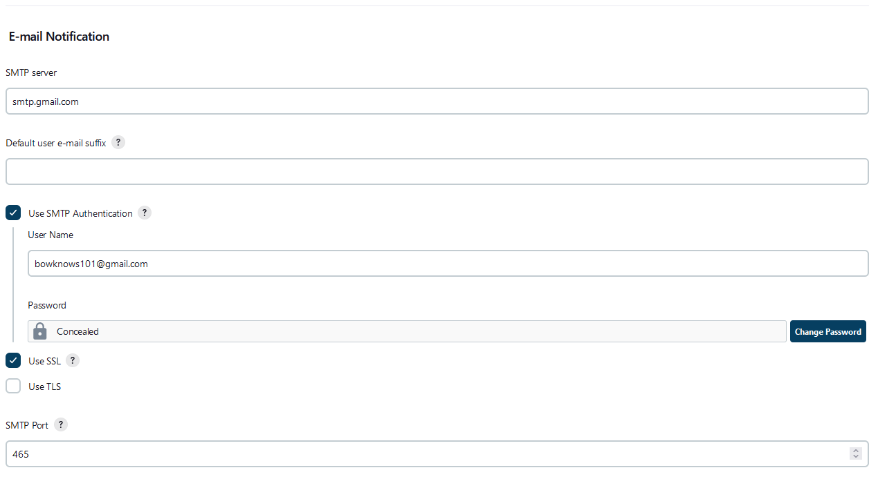
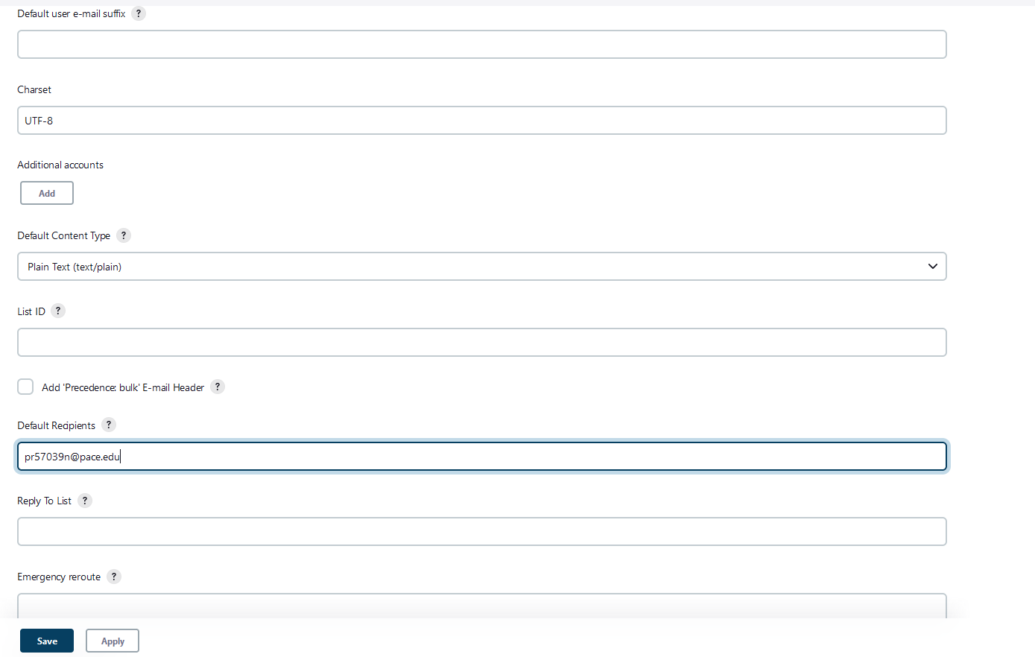
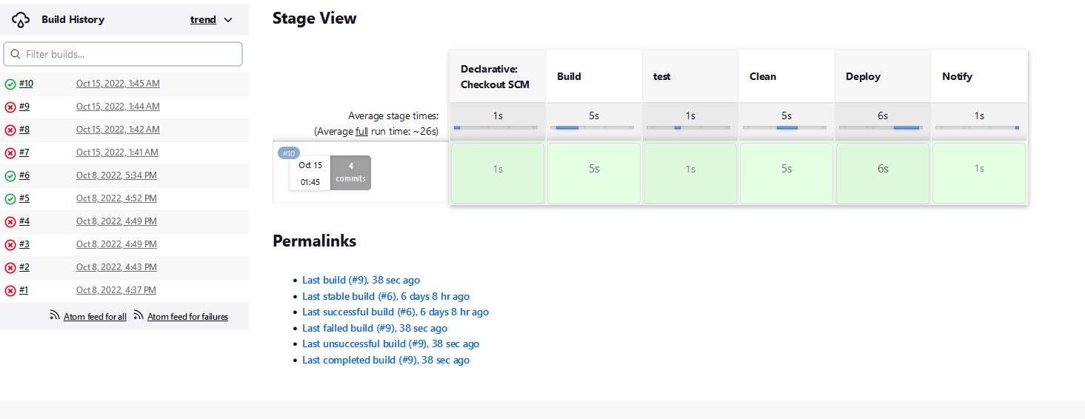
- 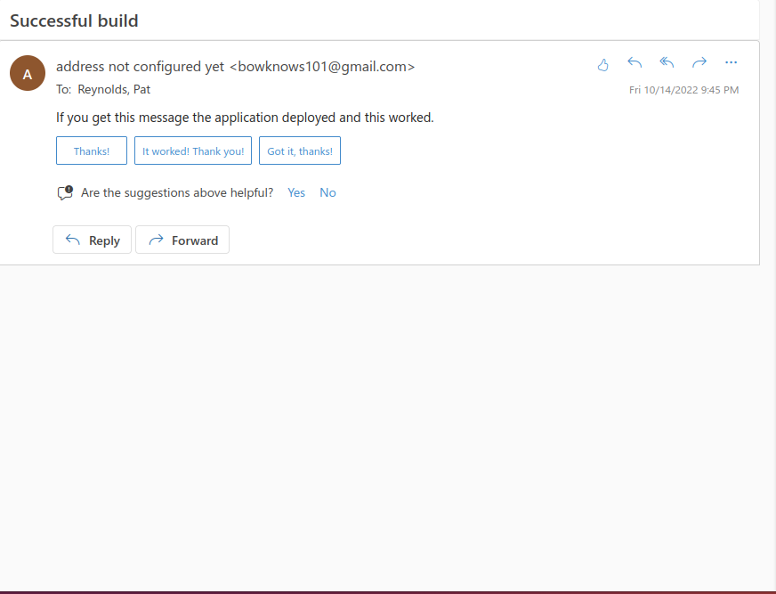

Issues:

- Email notifications for gmail using a normal password has been depreciated. You must have 2 factor authentication enabled and use an application password in order to use it as a mailer.
- Jenkinsfile syntax is crucial when adding steps. If {‘s and }’s aren’t fully placed in the right areas, Jenkins will refuse to even begin to do any steps.
- Returning to the EC2’s after a few days meant I needed to change the IP address of the agent, or else the request would time out.

Improvements:

- Overall, it seems the most frequent mistakes that occur during a deployment end up being related to either the Jenkinsfile, or how it handles processes after they finish their stage. So as best practice I would probably download the keep running Plugin from the start.
- At this point it is becoming more evident the pipeline can have as many, or as few stages as an individual would want. So a Pylinter would be a good idea to add for future deployments.
- During the deployment I was notified by amazon about my data usage, checking their terms for the free tier suggest that my usage heavily increased sending from entirely different vpcs instead of deploying to another subnet within the same vpc.
- Considering we’re using Linux and (e)NGINX, this stack seems aligned with the LEMUR stack (Linux, NGINX (Engine-x), MariaDB, Unit, and Redis.) rather than just the LAMP stack. (LAMP is an acronym for Linux, Apache, MySQL, and PHP.) So perhaps the other aspects can be integrated into a full development.

